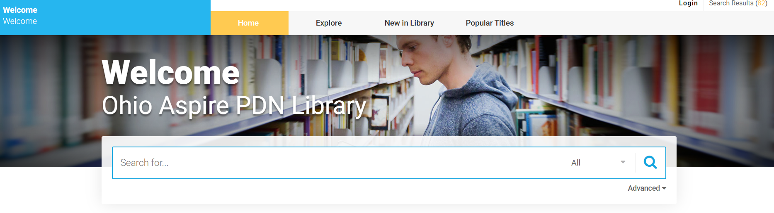

To log in to the library, go to http://ohioaspirelibrary.org.
When you see the “Welcome to Ohio Aspire PDN Library” page, click on “Login” at the top right corner. When prompted to log in, use your email from your PD System account. Your password is your first initial, last initial, plus you PD System ID number (e.g., Joe Teacher, 1234 – jt1234). Once logged in, you will be returned to the home page where you can search by Authors, Titles, Subject, or All.
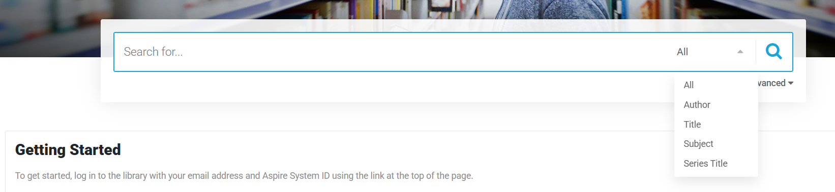

After you click the  button, a “Search Results” page will appear. There you have the option of adding items to your list by clicking on the “Add to List” button next to the item. Note: placing items on your list does NOT reserve items.
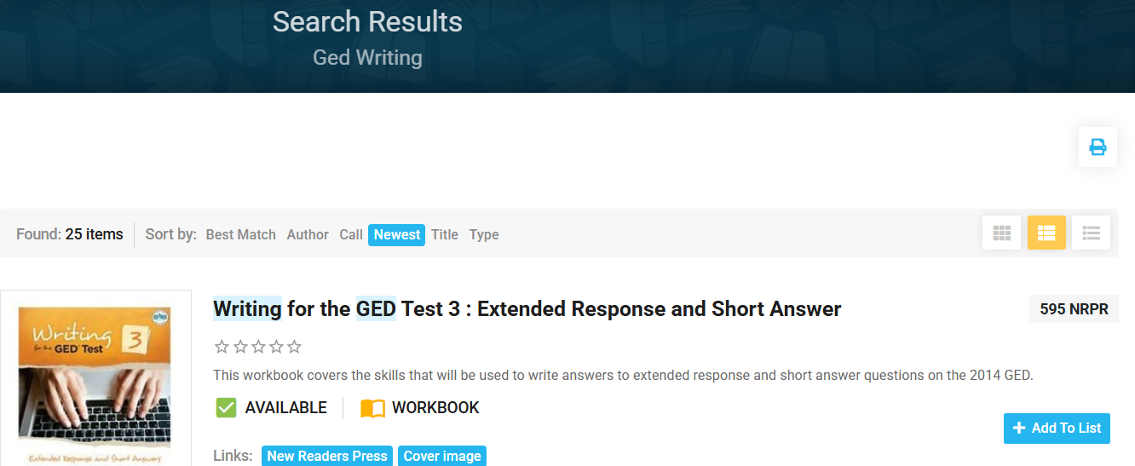

To reserve an item, click on the item title from “My List” or “Search Results” page. This will take you to the item level record with a “Hold” button next to the title and item description. Click on the “Hold” button to reserve an item. You will receive a confirmation message that the item will be mailed to you.


Once the reservation is confirmed, we will mail available items to you with a postage-paid return label.
For assistance, please contact the library@literacy.kent.edu.
Renewals
You can renew each item once online before the due date. Go to ohioaspirelibrary.org and click “Login” at the top of the page. Click on “My Account” at the top of the page. Click the “Renew” button next to the item description.

